AWS Account login And Instance Creation

Step 1:-Navigate to Google and Enter AWS Free Tier Account
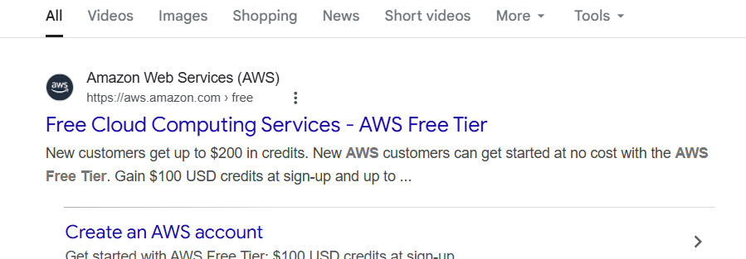

Step 2:-If you have no account Click on Create Account ,If have an account already Sign in to Console .
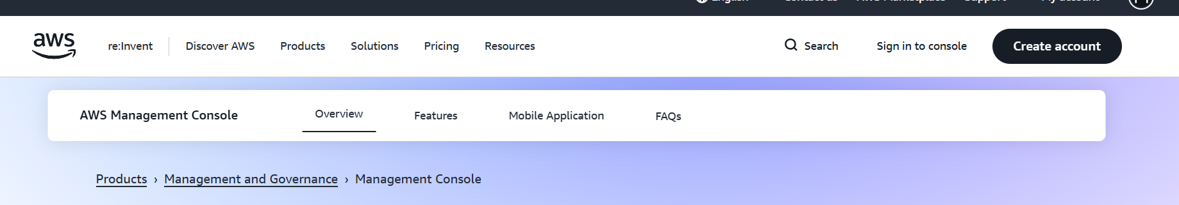

Step 3:- Login as a Root User, if you’re a root user,
IAM user created by the root user or an administrator.
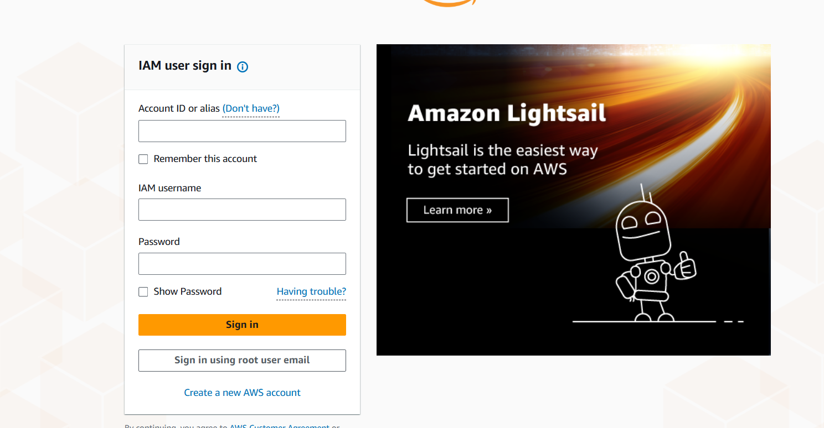
Step 4:- Give your Email ID and password
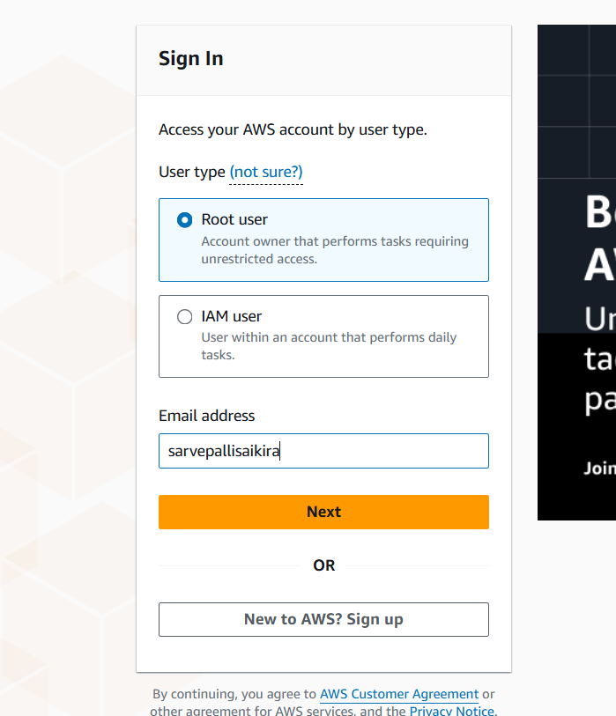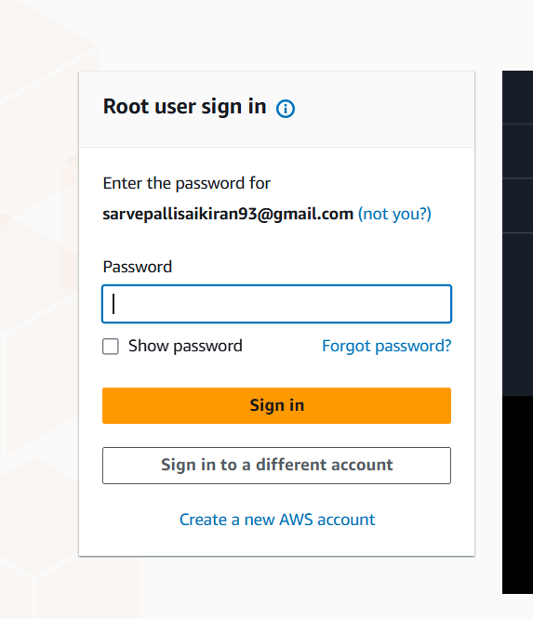

Step 5:- AWS Home Page is open
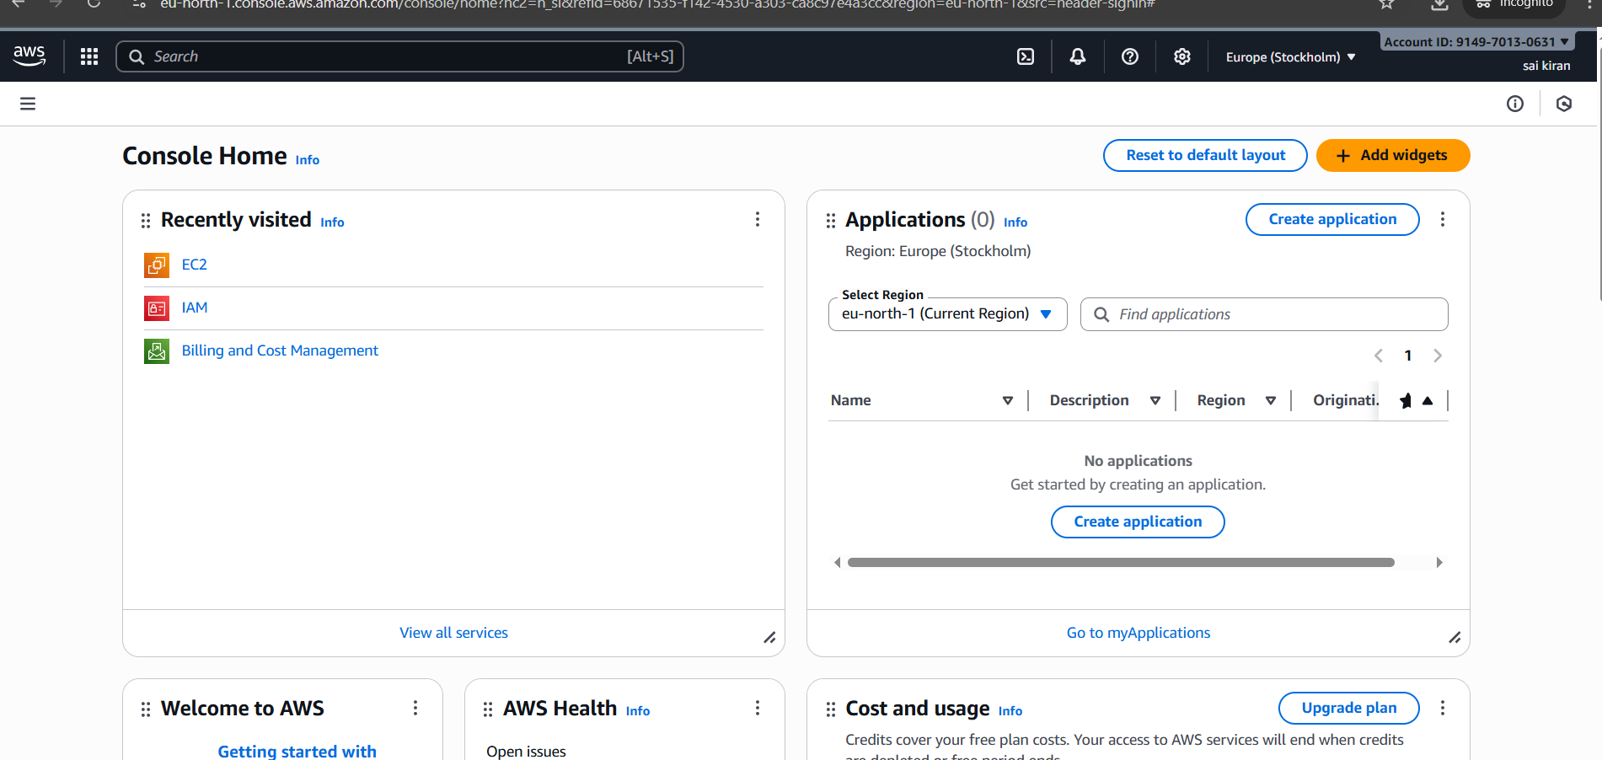

Step 6:- At top in search bar enter EC2 and open the EC2 (Elastic Compute Cloud)
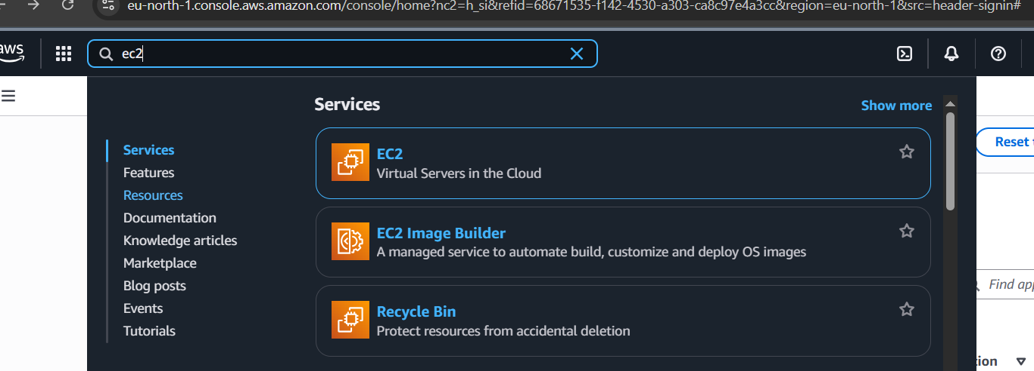

Step 7:-And click the instance
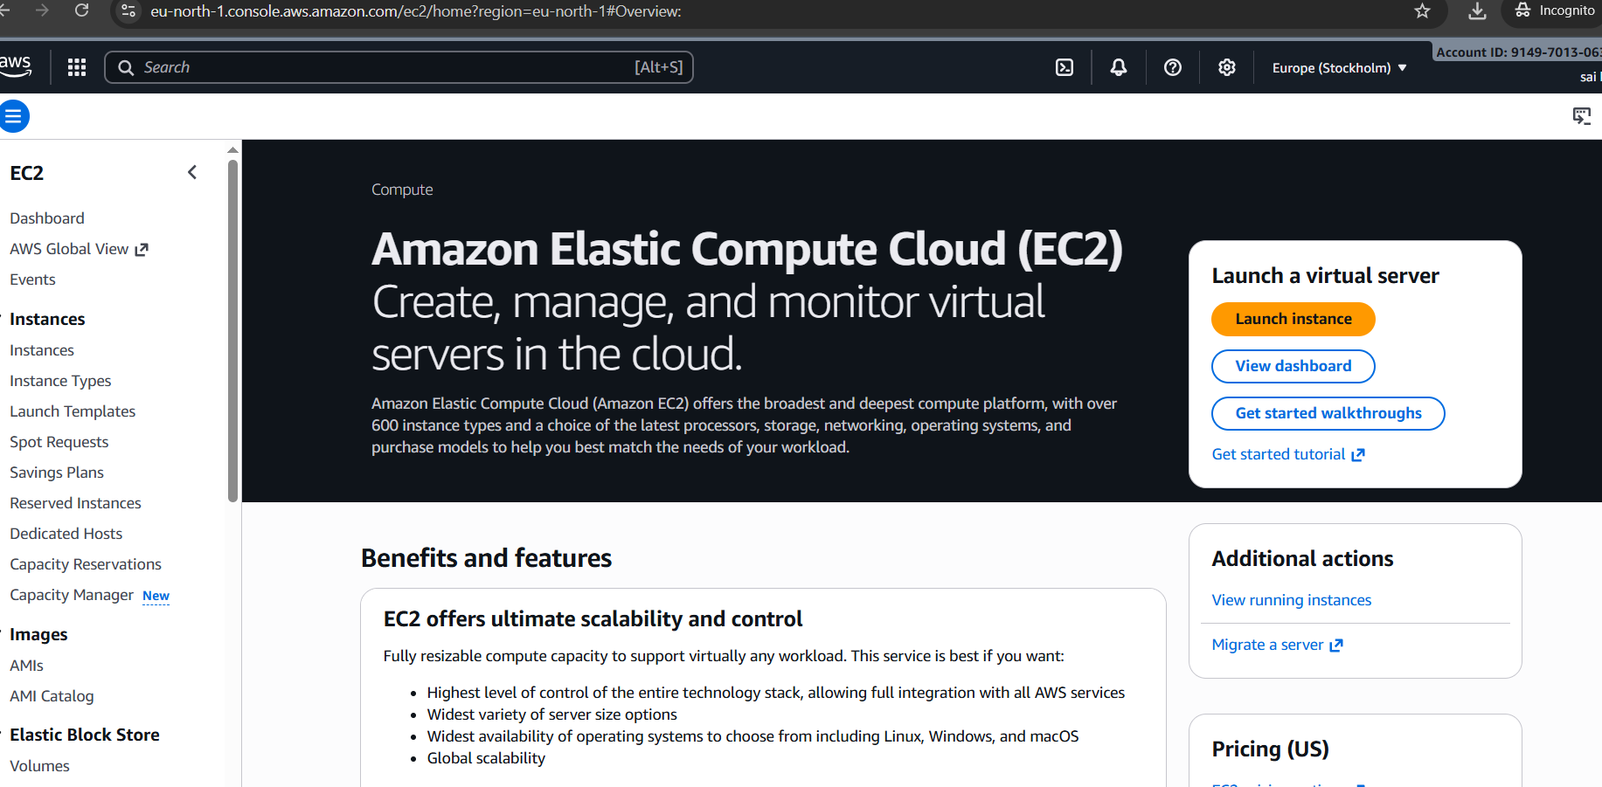

Step 8: - Click on lnstances and Active Instances Dashboard open and right top Click on Launch instance
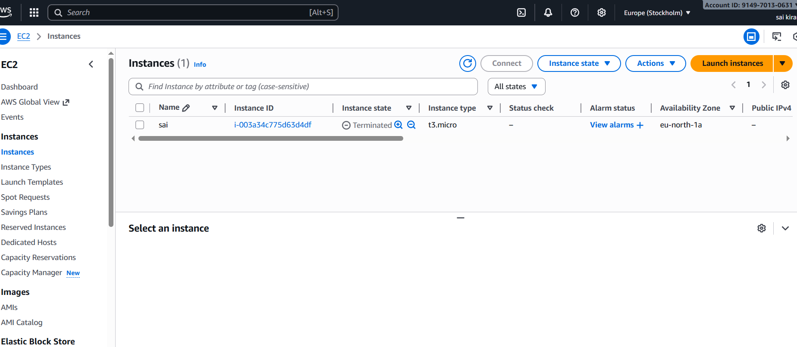
Step 9:-Give a Name for Instance and select ubuntu OS, here we have number of OS provide by the AWS here I am using the ubuntu

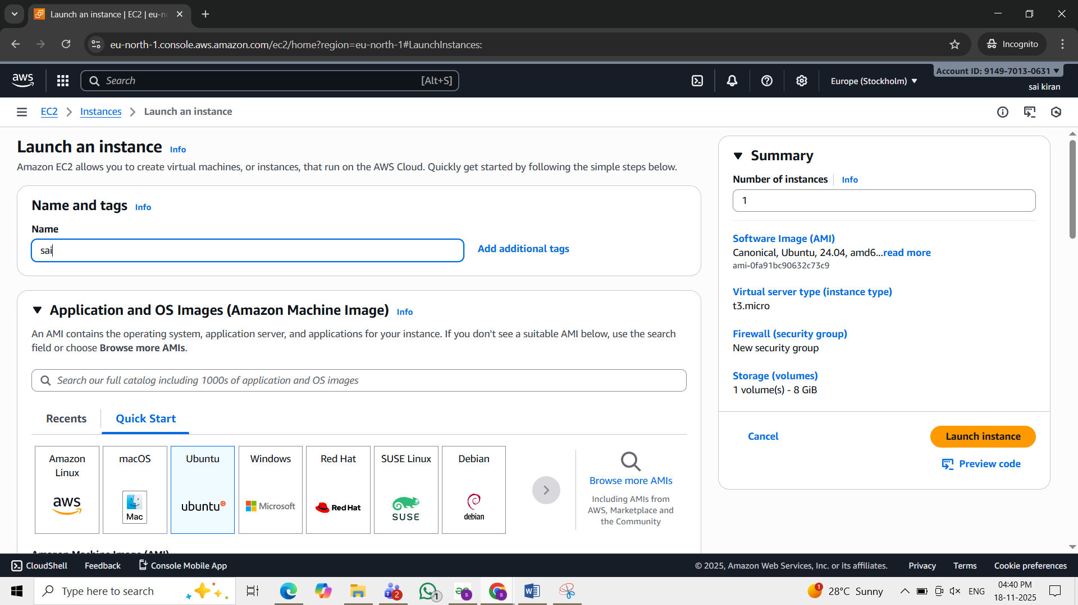
Step 10:- Select your Instance Type , Instance defines resources (CPU, memory, etc.) and a computing platform for allocating dev environments that you need
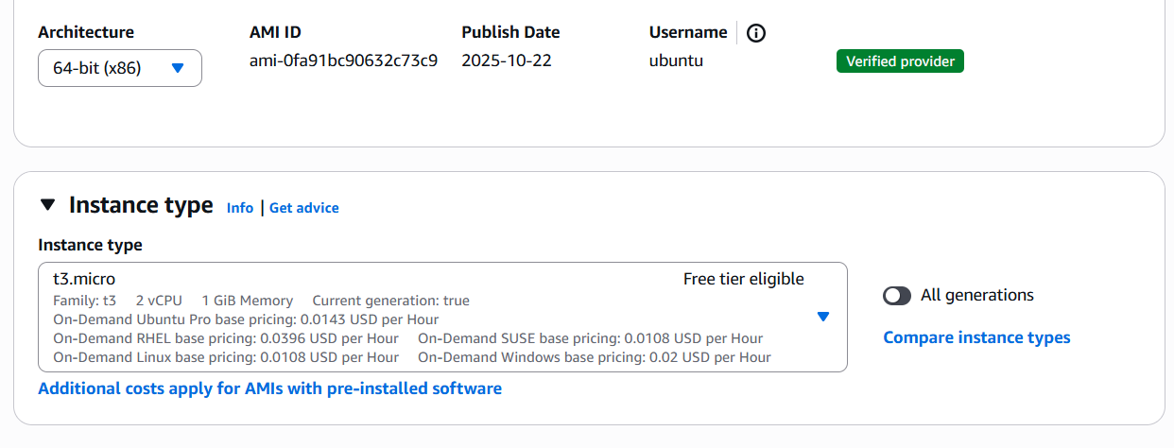

Step 11:- Give pair key
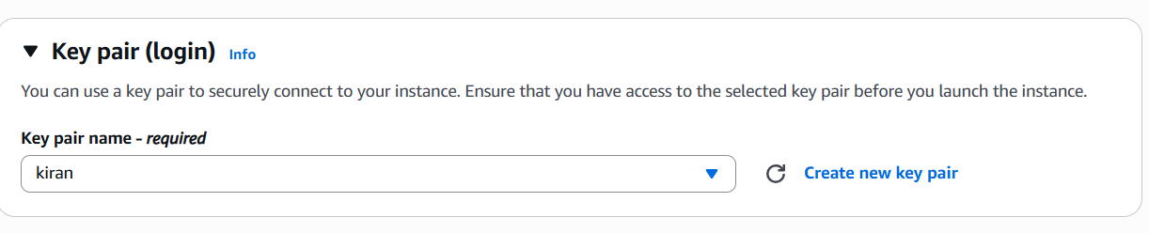

Step 12:- Create key pair and .pem file , A key pair is a combination of a public key that is used to encrypt data and a private key that is used to decrypt data.
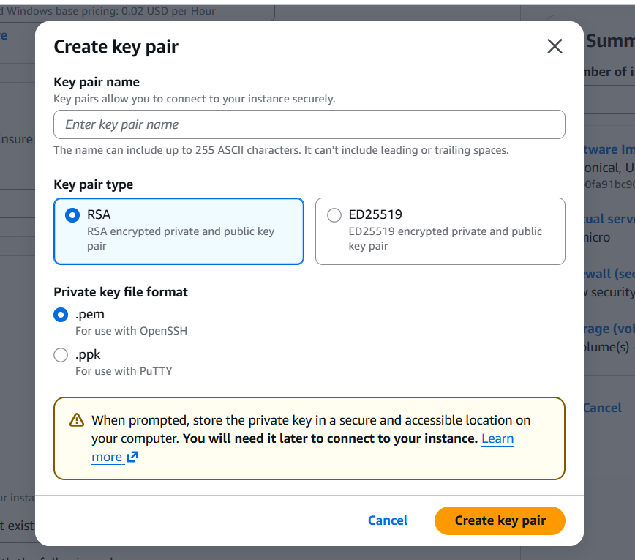

Step 13 :- .pem key file is download in device,A PEM file is a private key used to securely connect to your AWS EC2 instance using SSH
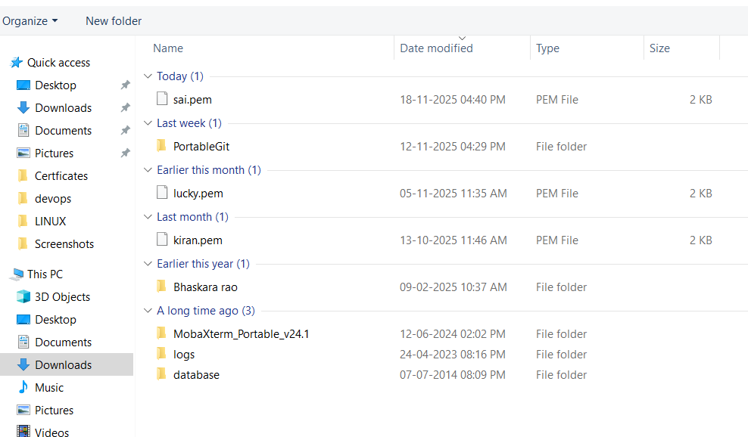

Step 14:-In network settings allow SSH
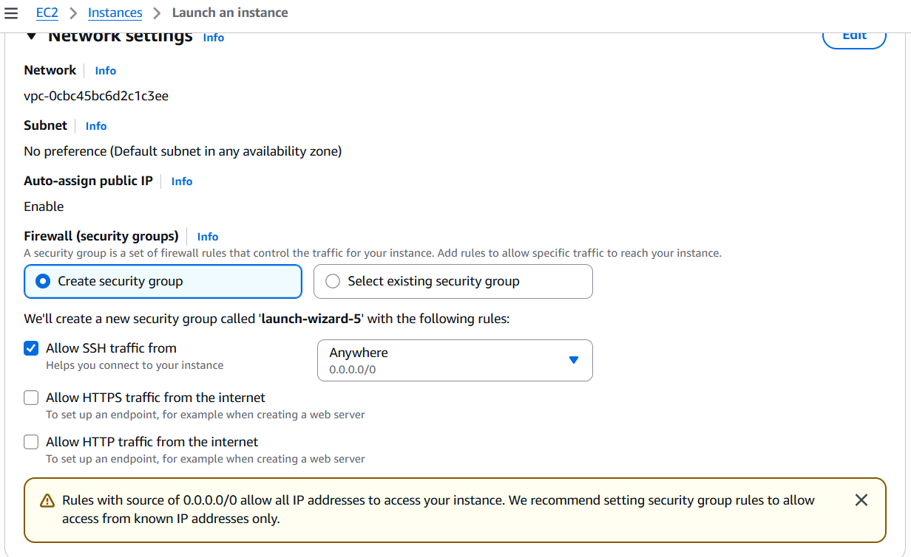

Step 15:- Check the Configure Storage
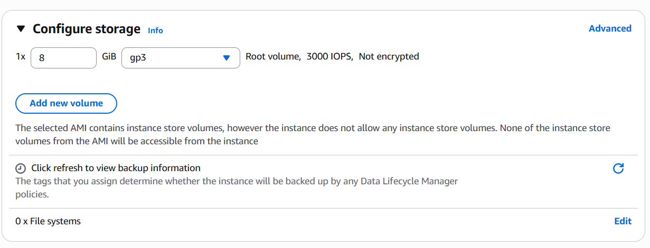

Step 16 :- Click on Launch instance
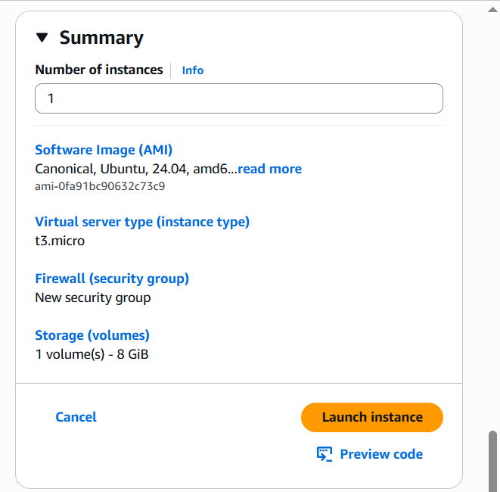

Step 17:- Instance launched successfully and instance ID is Generated
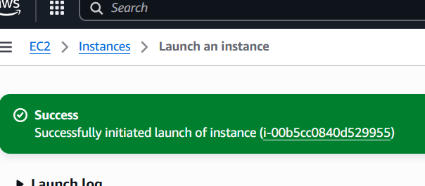

Step 18:-Select the created instance and Click on connect and it takes to the Instance ID page
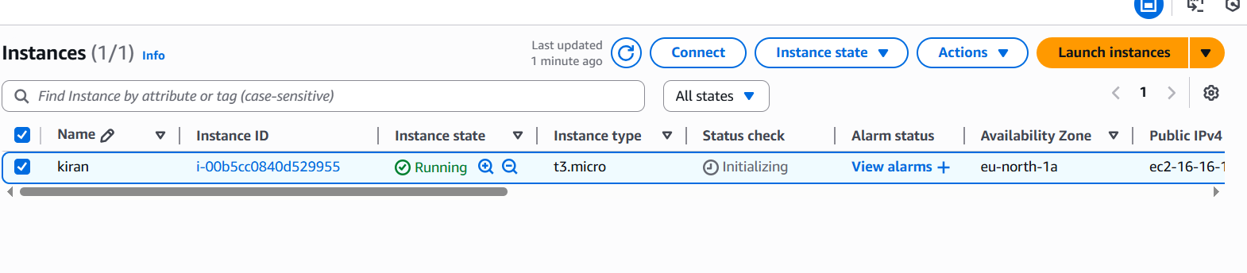
Step 19:- Go to SSH Client it has SSH(Secure Shell) pair key and using pair key in powershell we connect to the Ubuntu
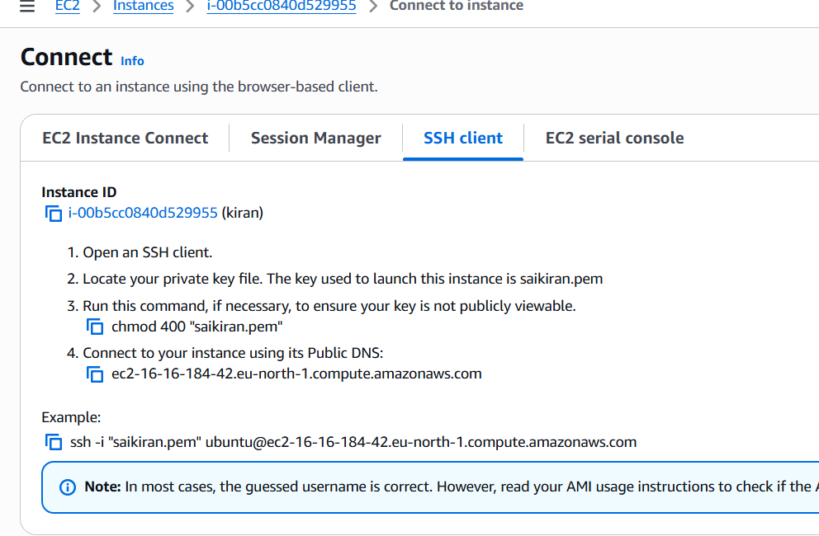

Step 20:- Open the Windows Powershell in your PC
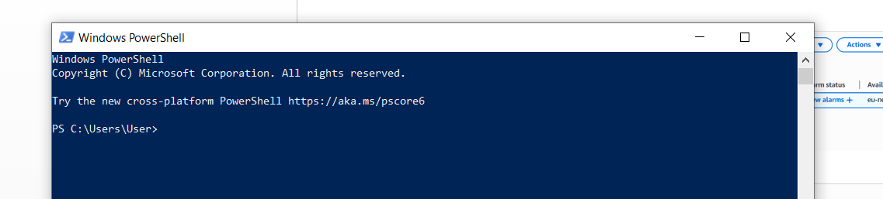

Step 21:- First we need to change the folder that we need to use command cd .\Downloads\ after we need to check the .pem file is download are not use the command ls .\saikiran.pem
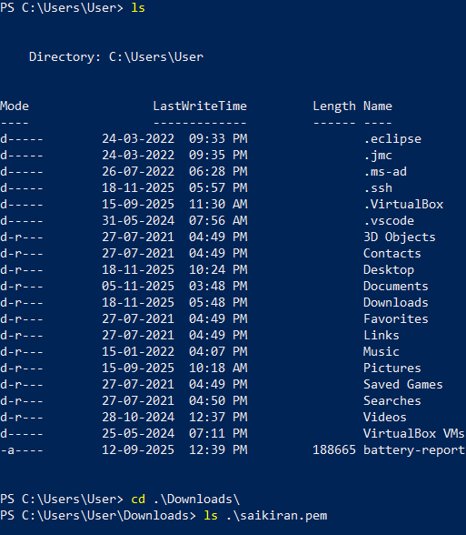

Step 22:-Then copy this SSH key (Secure Shell) ,TO connect the Ubuntu
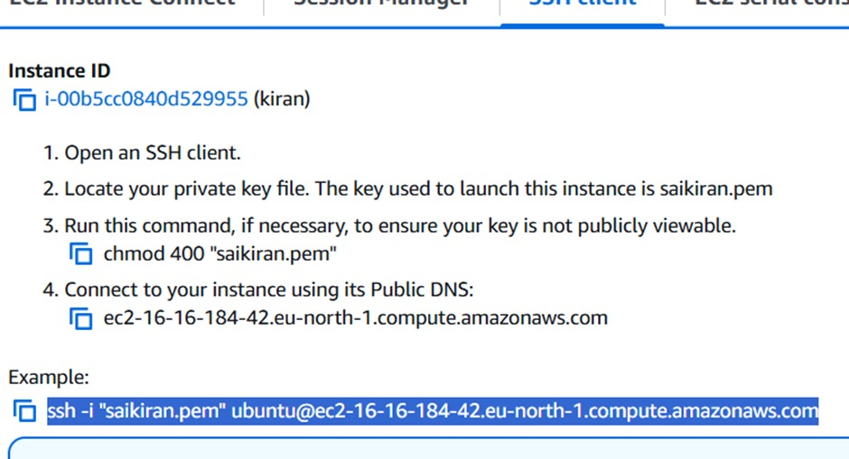

Step 23:-Paste the SSH key in powershell and it connect to the Ubuntu and type YES and connect to the ubuntu

Step 24:- Ubuntu is successfully installed in Window Powershell by using AWS

